**Step 5**

In CSS, you can target everything with an asterisk. Add a border to everything by using the * selector, and giving it a border of 1px solid black. This is a trick that helps visualize where elements are and their size. You will remove this later.

* {  
 border: 1px solid black  
}

# Step 6

Also add a box-sizing of border-box to everything. This will make it so the border you added doesn't add any size to your elements.

* {  
 border: 1px solid black;  
 box-sizing: border-box;  
}

# Step 7

You can see the body (it's the inner-most box on your page); the box around it is the html element. Make your body fill the whole viewport by giving it a height of 100vh. Remove the default margin from the body by setting the margin to 0. Finally, set the overflow property to hidden to hide any scroll bars that appear when something extends past the viewport.

# Step 21

The buildings are too spaced out. Squeeze them together by adding two empty div elements to the top of the background-buildings element, two more at the bottom of it, and one more in between .bb3 and .bb4. These will be added as evenly-spaced elements across the container, effectively moving the buildings closer to the center.

# Step 25

That didn't work, because the variables you declared in .bb1 do not cascade to the .bb2 and .bb3 sibling elements. That's just how CSS works. Because of this, variables are often declared in the :root selector. This is the highest level selector in CSS; putting your variables there will make them usable everywhere. Add the :root selector to the top of your stylesheet, and move all your variable declarations there.

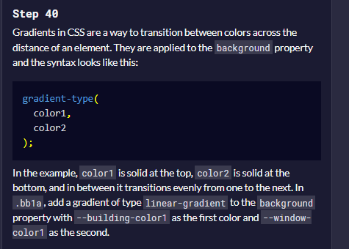

# Step 65

You want .bb4 to share the properties of .bb1 that center the sections. Instead of duplicating that code, create a new class above the background building comment called building-wrap. Leave it empty for now; this class will be used in a few places to save you some coding.

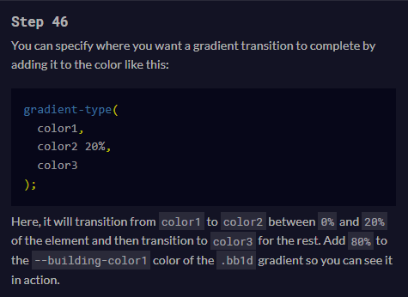

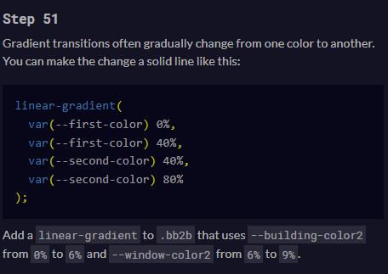

.bb2b {  
 width: 100%;  
 height: 100%;  
 background: linear-gradient(  
 var(--building-color2) 0%,  
 var(--building-color2) 6%,  
 var(--window-color2) 6%,  
 var(--window-color2) 9%,  
 );  
}

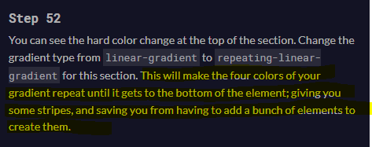

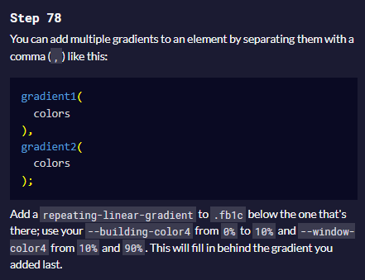

# Step 79

You're going to use some more border tricks for the top section. Add a border-bottom with a value of 7vh solid var(--building-color4) to .fb1a. This will put a 7vh height border on the bottom. But since the element has zero size, it only shows up as a 2px wide line from the 1px border that is on all the elements.

# Step 80

When you increase the size of the left and right borders, the border on the bottom will expand to be the width of the combined left and right border widths. Add 2vw solid transparent as the value of the border-left and border-right properties of .fb1a. They will be invisible, but it will make the border on the bottom 4vw wide.

# Step 113

At the top of the sky gradient color list, where you would put a direction for the gradient; add circle closest-corner at 15% 15%,. This will move the start of the gradient to 15% from the top and left. It will make it end at the closest-corner and it will maintain a circle shape. These are some keywords built into gradients to describe how it behaves.